Course Name | ITD 2343 – Object Oriented Programming with C#
Instructor | Mark L. Pranger
Student Name | Lauren Lashley
Due date | January 20, 2026
Grade | <grade earned here>
Grading Comments | <instructor comments here>

Section 1 - Week 1 to Week 3 Programming Lab

Screenshot 1 – IDE experience:
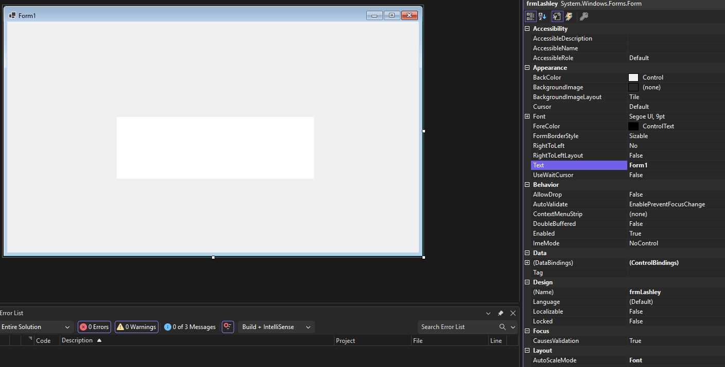
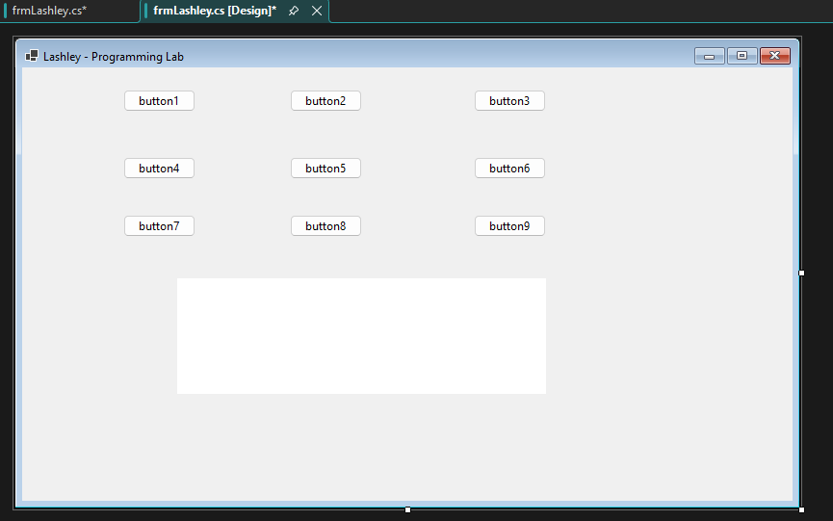
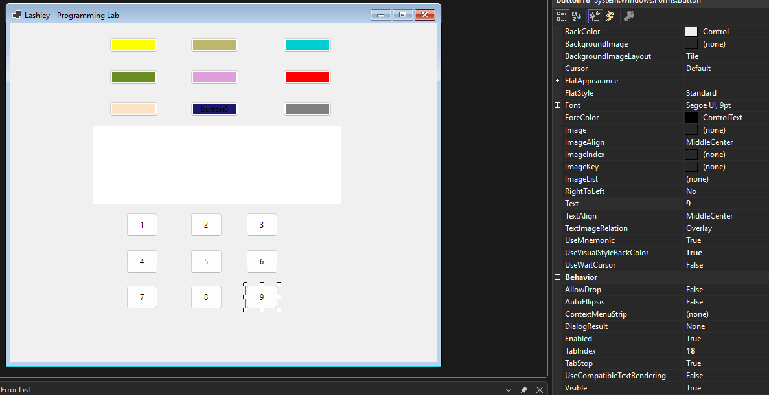

Screenshot 2 – the form when it starts:
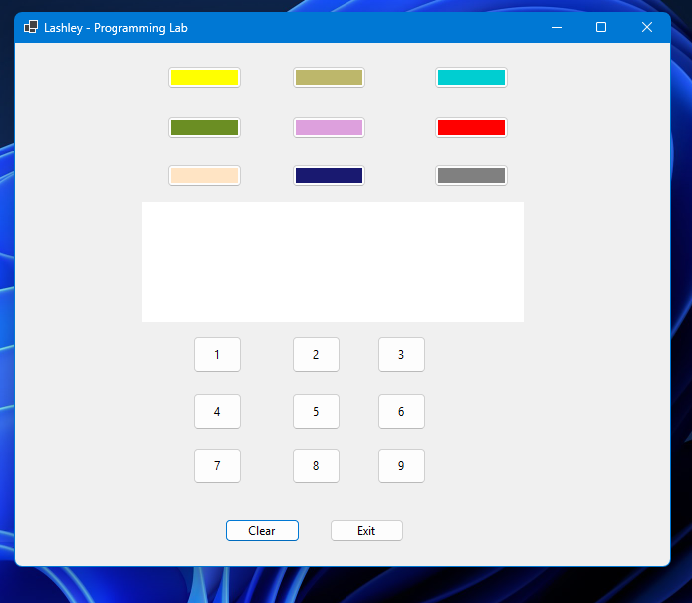

Screenshot 3 – Color pressed, no number:
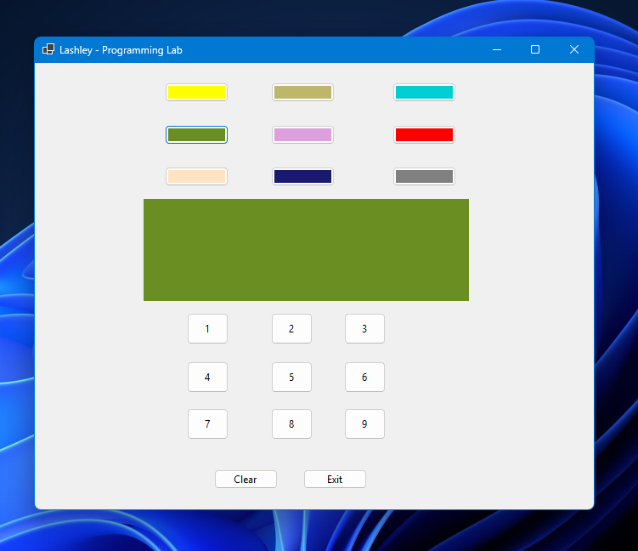

Screenshot 4 – Number pressed, no color:
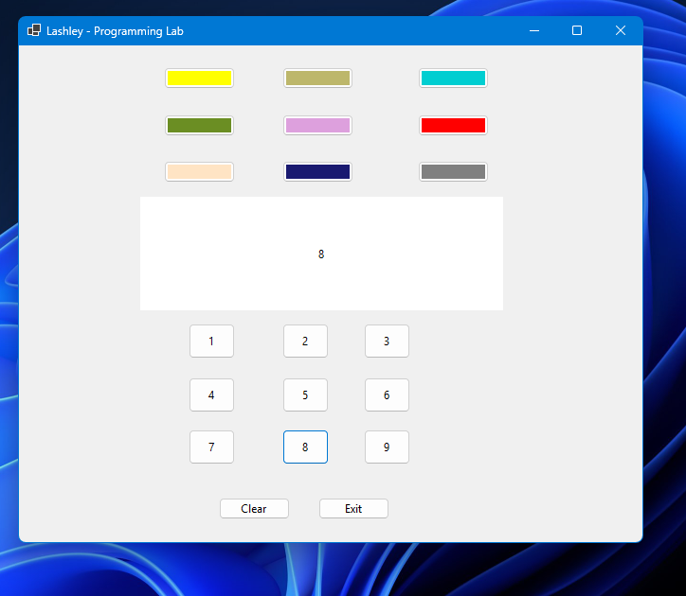

Screenshot 5 – Both color and number pressed:
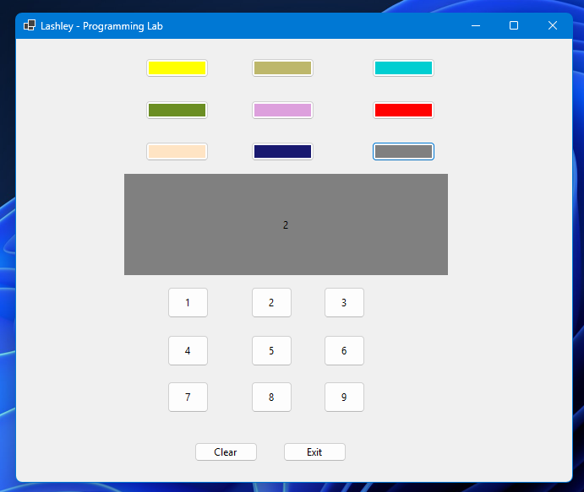

Screenshot 6 – Clear button pushed:
